Quanta Computer Corporation
Name
Institutional Affiliations

Quanta Computer Corporation
The Blue Ocean Strategy was a term coined by Kim and his colleague. The term is used to refer to a simultaneous follow of differentiation as the Company tends to become global. In the entire process of differentiation, a Company may also aim to lower its production costs in the new market or space. With the increased competition in the current market, a company may also closely aim at attracting high demand. This can only be achieved by obtaining the unoccupied market space, making the existing competition irrelevant (TN, & Kim, 2008). The view proposed by the authors is basically based on the fact that there are no quite described market boundaries and industrial structures which may bias actions in the market. In Blue Oceans, demand simply created but not scrambled over because of the presence of opportunities for profitability and growth (Kohnen, 2006).
The Quanta Computer is an international Company which is based in Taiwan. It specializes in the manufacture of computers and other electronic hardware. Majority of the consumers are from the Dell, Apple Inc. and Amazon.com (Dean, & Tam, 2005). The Company has it’s headquarter in Taoyuan, Taiwan.
Quanta Computer’s Mission Statement
“The Company combines technology and humanity to drive to excellence in research, development and manufacturing of products, services and solutions that enhance the welfare of all mankind"

Vision Statement
“Quanta Computers is dedicated to integrating software and hardware. Providing solutions, meeting the demands of the users and constantly bridging the human-centred values to the human society" (Huang, 2001).
Corporate Structure
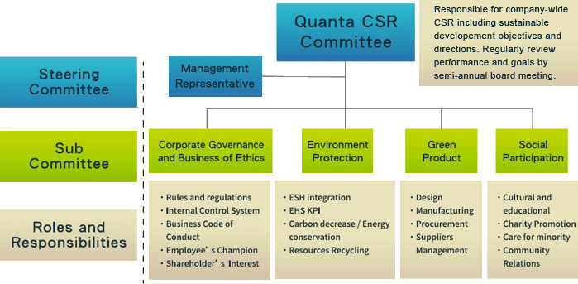
Quanta computer’s corporate structure is so ideal that at the top is the committee responsible for the corporate social responsibility (CSR). The main responsibility of this committee is in sustaining development objectives as well as the provision of directions. On regular basis, they review the performance and the established goals of the semi-annual board meetings (Dean, & Tam, 2005). Below this management body is the corporate governance body which is responsible for the formation and regulation of rules, control of the Company’s internal system, championing of the employee and shareholder’s interests. Ideally, the organizational structure is guided by principles of environmental protection, social participation and Green products.
Organizational structure
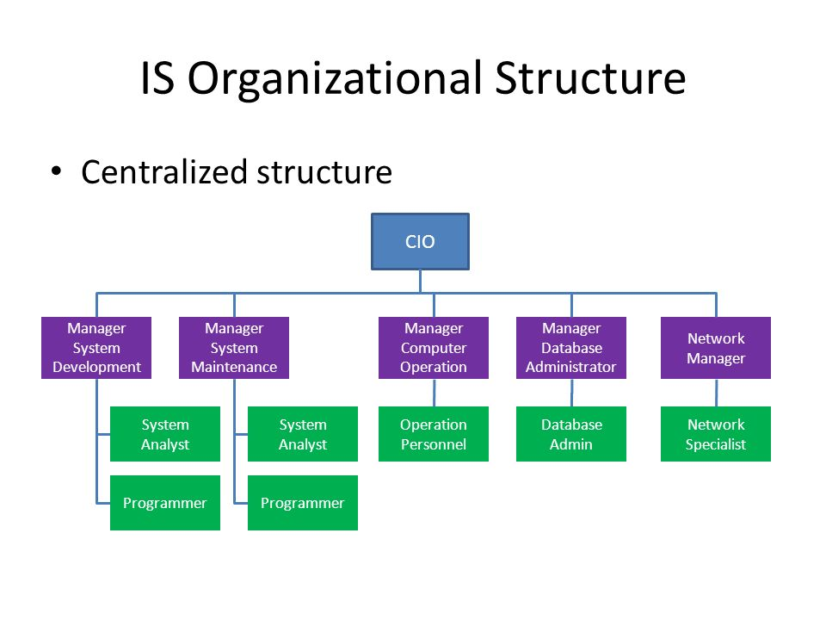
The Company's Organizational structure is centralized with the CIO at the topmost position. Immediately below the leader are the managers responsible for system development, system maintenance, computer operations, database administration and Network management (Huang, 2001). The system development manager works closely with the system analysts and the programmer while at the computer operations are the operational personnel. At the department of administration is the database administrator. The network manager, on the other hand, works in coordination with the network specialist.

Products and Services
Quanta Computers established in 1988 have risen above the grounds to become one of the world’s major notebook computer providers in the world. The company uses high mechanized and developed technology to provide quality designs and services to computer manufacturing companies across the world. For the past decade, Quanta has specialized in the introduction of fully weighed computers. This is a mileage from the actual provision of the lightweights. Additionally, the Company provides high-performance servers in response to the increasing demand of the cloud computing management (Huang, 2001). Furthermore, the Company has invested more in augmented reality, Virtual reality as well as mixed reality area in attempts to capture many market opportunities. With regards to the ‘blue oceans' proposed by Kim, Quanta has also focused on the use of advanced technology in the medical fields in order to diversify on the current business model.
Resource Availability
Quanta's resources are mainly attributed in terms of the level of technology and the abundant labour supply across the globe. As discussed in the context above, the Company is a leader in the high technology markets. This is the case courtesy of the available global well-advanced technology. The Company incorporates the current available worldwide technological resources in the creation of its products. With this fact, the Company has always benefited from technological resources which are ideal in the design, development and manufacture of quality and high value-added solutions and products for their customers. Consequently, the Company has abundant labor resources. Owing to the fact that the Company operates in many global countries, it has employed over 30000 employees (Kohnen, 2006). Majority of the employees work in the engineering departments, while some are in managerial positions as discussed above.
Other information
Quanta computers are going global at a very fast speed because of the quality products and respect to the CSR. The company opened another repair facility in 2003 in Nashville. Besides, operations have been increased to South America, North America, Asia and Europe. The aim of this expansion has been to manufacture and configure service products in addition to the provision of logistics in support of the delivery process. The major milestone was the recognition by the Fortune magazine as a member of the Global Fortune 500 originality.

References
Dean, J., & Tam, P. W. (2005). The laptop trail. The Wall Street Journal, 9, B1.
Huang, J. H. (2001). The notebook niche. In Made By Taiwan: Booming in the Information Technology Era (pp. 172-193).
Kohnen, J. B. (2006). Blue ocean strategy: how to create uncontested market space and make the competition irrelevant. The Quality Management Journal, 13(3), 61.
TN, S. K. (2008). Blue ocean strategy: how to create uncontested market space and make the competition irrelevant. South Asian Journal of Management, 15(2), 121.

